file: CHANGES.DOC
date: 25.06.2001

Changes in Remote Control Software (LEADER version)

1. Help - About:
- Software version changed to 2.0
- Logos, address,http and email address changed to DK-Audio

2. Genlock window:
- The System drop-down now contains:
Internal
PAL
NTSC
10 MHz

instead of

Internal
PAL burst
NTSC burst
10 MHz

3. Black Burst window:
- The System drop-down now contains:
PAL
PAL w. ID
NTSC America
NTSC Japan

instead of

PAL
PAL with ID
NTSC

4. TSG window:
- Title changed to 'Edit SDI settings'
- System drop-down changed as in BB window
- 'Analog Settings' and 'SDI Settings' tab sheets interchanged,
SDI Settings tab sheet has now Embedded Audio drop-down
Analog Settings now has ScH Phase

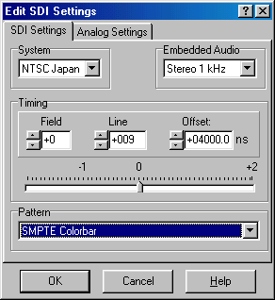
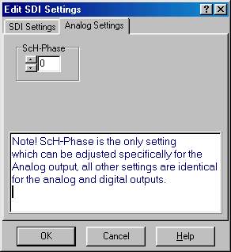
- In case of NTSC systems, we now have
FF Color Bar ITU 801
instead of
EBU Color Bar ITU801

5. Audio window:
- Audio level of -21 dB changed to -20 dB for both Analog and AES/EBU
audio
- The fields
- PLL
- Video
are now removed

6.Response Window:
KU-number changed to 'Serial Number'

7. Front Panel:
- 'PT5201' changed to 'LT428'
- 'ProTeleVision' changed to 'LEADER'
- 'COLORBAR' changed to 'SDI'
- 'Varitime' word removed

8. General
- All file names (*.ini, *.hlp, *.exe) changed to LT428
- New commands implemented for:
NTSC Japan (JNTSC)
NTSC America (NTSC)
-20 dB (-20)
which means that the software is not compatible with old generator
software.

:JK
end of file

